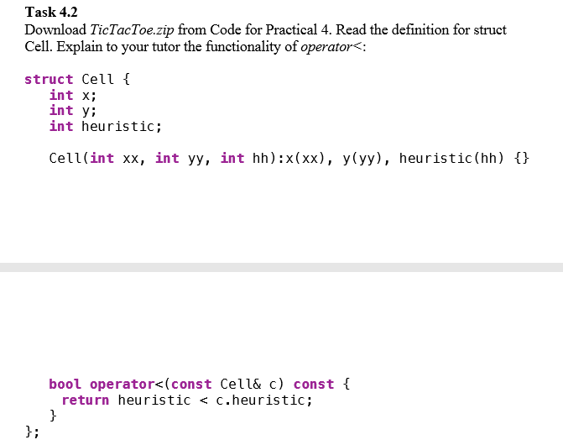We overloaded the operator, with the intention of trying to determine which value is greater than the other. This is very useful if you want to implement a priority queue, and can help a person implement an AI with ability to pick the best decision. If the action is an object, overloading the operator is necessary.